|  |
| --- |
| Close-up image showing the leaf-sides of two oversized books side-by-side on a bookshelf, with additional books in soft focus background |
| Library Books Recommendation System  CS2003 Usability Engineering |
| |  |  |  | | --- | --- | --- | | **Group 27** |  | **Franco, Phuthi, Anas, Romi, Anathany, Philipe, Cameron** | |

## Evaluation Method

Usability evaluation does not answer the question “Does the software achieve its task?”, but it focuses on how well and in what way, the software assists the user in achieving his or her task.

Before starting to analyze what evaluation method best suits the software that we are developing, here are some useful definitions:

**Evaluation:** a process through which information about the usability of a system is gathered in order to improve the system or to assess a completed interface.

**Evaluation method:** a procedure for collecting relevant data about the operation and usability of a computer system.

Group 27 is developing an application to help users find the book they want, getting rid of the old traditional way of physically going to the library and enquire about the book, but instead with a simple click getting direction to the exact location of the book. Also, through a review system the user will be able to read reviews and thoughts about the product of previous readers. We are therefore assessing:

* 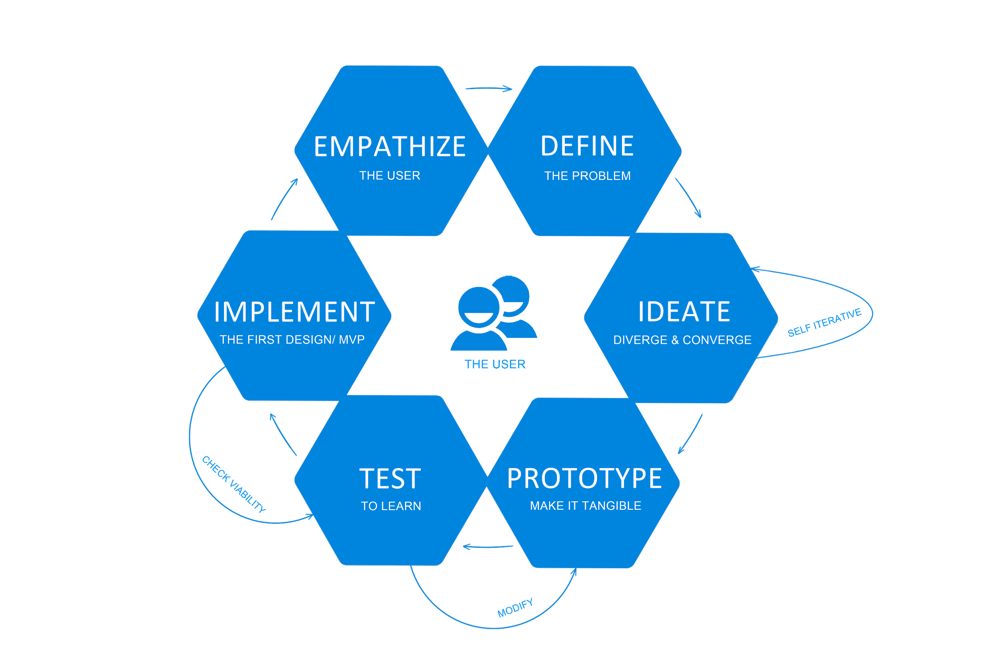Users of all ages with access to a smartphone and strong interest in reading.
* Everyday users who read for pleasure, for studies or for research but constantly.
* Users in a university environment who deal with looking for the same book all at once
* As studies demonstrate most applications related to books and reading focus on transferring the activity from paper to digital, however this application will focus on guiding the user digitally to get the physical paper. Therefore, there is no similar software to relate to.

Start Methodology Lifecycle

### Star Method

The star life cycle is a method that focuses on evaluation, being the center of the whole method. After completing a step of the software development cycle the work done is evaluated, if successful meaning that evaluation and the purpose of serving the user to help him achieve its goal easier, then we can move on to the next step, otherwise the work has to be done again until it meets the criteria stated by the evaluation. This is done for each step in the software development life cycle.

### Why Star Method?

Being group 27 composed by 7 members each one will have a weekly task to complete in order to work all as a whole and reach the goal faster and more effectively. Every Thursday from 11 am to 13 pm there will be scrum meetings, these will serve as Evaluation just like the star in the middle of all processes, where all the members reunite to discuss together the work done and evaluate it, unanimously choosing whether to accept it or not if it does not fit the scope of the software.

## Heuristic Evaluation

|  |  |  |
| --- | --- | --- |
|  | Current System | New System |
| Visibility of System Status | Current system is very confusing. Upon surveying, we found that users usually get confused when they see the homepage of our current library system. | New system showed positive results, as users found the new system very easy to use. System clearly indicated what’s the current status by highlighting the button on the menu bar. |
| Match between the system and the real world. | System takes the user to the home base of the webapp first, then asks them to login, which is very illogical. | New system follows real-world conventions. If you are supposed to walk in a library, you are required to tap your ID first, then enter. Same method is implemented, where it is mandatory to login first then browse the app. |
| Consistency and Standards | It is common understanding that once pressed on the logo of any app, it takes you back to the homepage of the system. However, the current system doesn’t do that. This breaks the external consistency.  Furthermore, two different dropdown designs are used on websites, this breaks the internal consistency. | New system has resolved this issue and will void adding anything to user cognitive load.  New system also uses shade of color to highlight actionable elements, i.e. current page they are on. |
| Error Prevention | Overdue; System automatically renews the books that users have borrowed up to 3/4 months. This could cover into error in future, as users might forget to return the book over ¾ month duration and will end up with overdue fee charges. | To prevent this error; system will give out notification to users and ask them to manually renew it or return the book. By adding this way, users will get a reminder of what the status of the book they borrowed. |
| Recognition and Recall | We found from a survey that the method of searching books in the current system is very confusing. Users are provided with 5 search options/buttons. This requires the user to recall before deciding which method to use for searching a book. | New system has brought down the search option to 3. However, all are named properly so users can quickly recognize the method they want to use. |
| Aesthetic and Minimalist Design | Twitter bar: Current system provides twitter bar on app. Yes, it adds to the aesthetics but not many users take full advantage of it. It also diverts the user mind from the core principle of the app. | Something opposite ?? |
| Help and Documentation | Current system doesn’t provide any help with locating books apart from telling the shelf name/number and area the book is in, i.e. Computer Science, Law, etc. | New system provides users with a map of the library and calculates the route from current location to book’s location. Locating books will be easy as we are providing visual prominent steps (map) for the user to follow, rather than reading the documentation. |

|  |  |  |  |  |  |
| --- | --- | --- | --- | --- | --- |
| **Heuristic Evaluation** | | | | | |
|  | **Version 1** | **Version 2** | **Version 3** | **Version 4** |
| Visibility of System Status | Inadequate  The System doesn’t indicate the status of the current page. i.e. some of the pages are missing titles. | Good  Changes were made and titles are added to all pages now. On the signup page, once text is filled up it, green borders should appear to let the user know its valid input. | Excellent.  Discussed changes were made. No further recommendations were made. | N/a  Or  No further changes were made. ??  You choose Franco |
| User Control and Freedom | Poor  The system should provide the user to cancel any step taken. Sign up page doesn’t have a cancel button. | Good  Back button was added on sign up page, However, the Home page doesn’t provide logout option. | Good  Logout button is hidden within the “More” option. This could lead to confusion user; hence it should be located where user can easily access it. | Excellent.  Logout Button was relocated, and the system provides complete freedom to opt-out from any action taken. |
| Match between the system and the real world. | Good  Name choice for buttons can be improved. Using “cancel” instead of “Back” would be more appropriate. | Excellent.  Changes were made. This should help minimize the difference between other system and our system | N/a  Or  No further changes were made. ??  You choose Franco | N/a  Or  No further changes were made. ??  You choose Franco |
|  |  |  |  |  |
| Consistency and Standards | Poor  Different Button style is used within a system. | Good  Button style was made consistent.  The System breaks external consistency as no help feature is provided within the new system. | Excellent  Help page was added to the system. | N/a  Or  No further changes were made. ??  You choose Franco |
| Error Prevention | Poor:  The System automatically renews the books that users have borrowed up to 3/4 months. This could convert into error in future, as users might forget to return the book over 3/4-month duration and will end up with overdue fee charges. | Excellent  The system will give out a notification to users and ask them to manually renew it or return the book. By adding this way, users will get a reminder of what the status of the book they borrowed. | N/a  Or  No further changes were made. ??  You choose Franco | N/a N/a  Or  No further changes were made. ??  You choose Franco |
| Flexibility and Efficiency of use, | Poor: Only one search option is provided. If the system provides a different category to search by, it will be easier for the user to quickly find the books they are looking for. | Good:  New search categories are added; however, it only includes, search bar and genre. | Excellent  New option of “My list” and “Popular Picks” are added. This will provide ease of use | N/A N/a  Or  No further changes were made. ??  You choose Franco |
| Recognition vs recall in the user interface. | Very good:  All system options are clearly labelled. User will easily able to search it by genera, author, name, my list, popular pick and etc. | N/a  Or  No further changes were made. ??  You choose Franco | N/a  Or  No further changes were made. ??  You choose Franco | N/a  Or  No further changes were made. ??  You choose Franco |
| Help and Documentation | Poor:  Standard text is provided indicating the floor and shelf number to help the user locate books. | Good:  The Option of scanning the by bar code and giving book location in pop up menu was implemented but this is still not good enough. | Very good:  In build map system was implemented, where a user scans bar code and books location are shown on the map. However, no route/direction was provided. | Excellent:  Once the user scans the book, map route will appear, showing direction between the user’s current location and book. User can easily follow the direction and locate the book. |